Create a Bash script to monitor CPU usage.
- If CPU > 80%, then send an email notification.
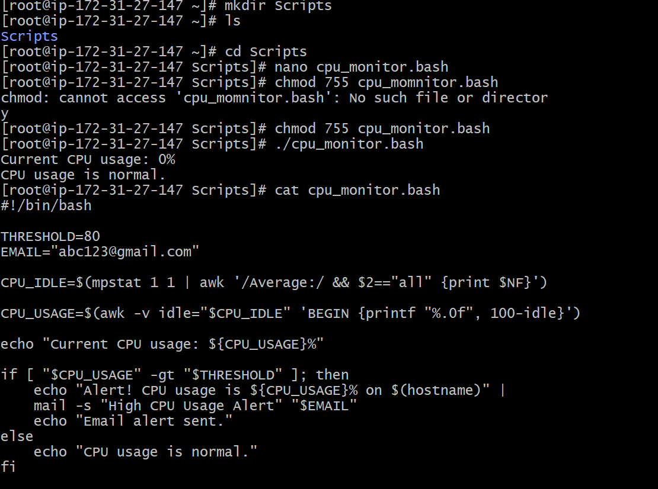
- Therefore, here we have created a directory script in order to store all our scripts based on bash.
- In that we have created a file naming cpu_monitor.bash to store the scripts to trigger automatic email notification if the cpu usage exceeds 80%.
- There we have created a script based on if condition.
Create a Bash script to monitor Disk Space.
- If usage > 80%, then send an email notification.
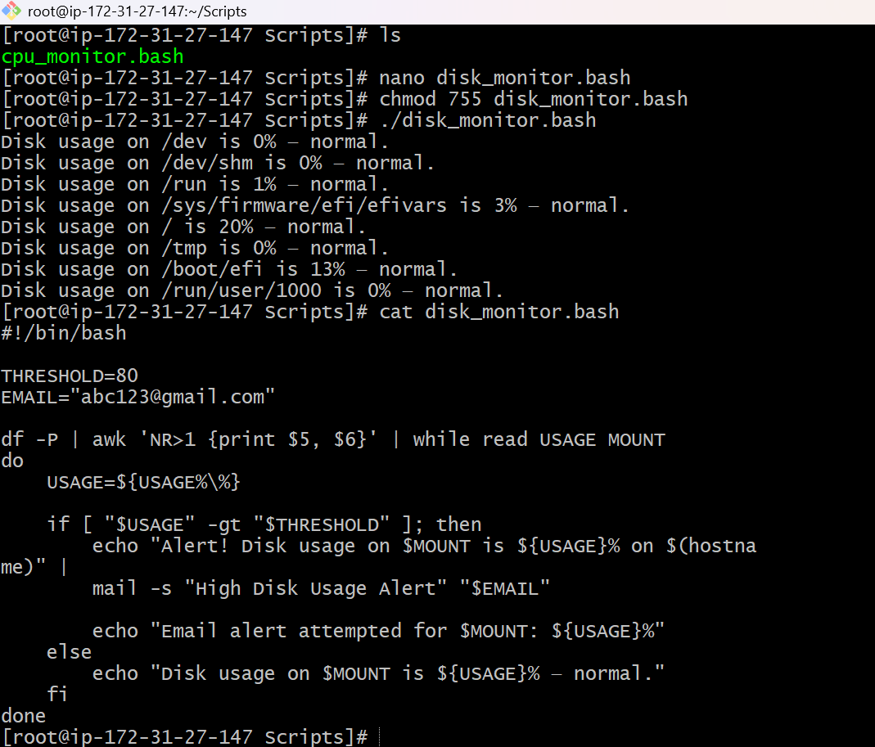
Disk Space Monitoring Using Bash Script
Objective
To monitor disk space usage on a Linux server and send an email notification if disk usage exceeds 80%.
Explanation of the Script
- #!/bin/bash
Specifies that the script should run using the Bash shell.
- THRESHOLD=80
Sets the disk usage limit to 80%.
- EMAIL="abc123@gmail.com"
Specifies the email address that should receive the alert.
- df -P
Displays disk space usage for mounted filesystems in a consistent format.
- awk 'NR>1 {print $5, $6}'
Skips the heading and extracts the disk usage percentage and mount location.
- while read USAGE MOUNT
Reads each filesystem's usage percentage and mount location one by one.
- USAGE=${USAGE%\%}
Removes the % symbol so the usage can be compared as a number.
- if [ "$USAGE" -gt "$THRESHOLD"]
Checks whether disk usage is greater than 80%.
- mail -s "High Disk Usage Alert" "$EMAIL"
Attempts to send an email notification if disk usage exceeds the limit. Email delivery requires a working mail configuration.
- else
Runs when disk usage is 80% or less and displays a normal status message.
- done
Marks the end of the loop that checks each filesystem.

Create a Bash script to monitor Memory Usage.
- If usage > 80%, then send an email notification.
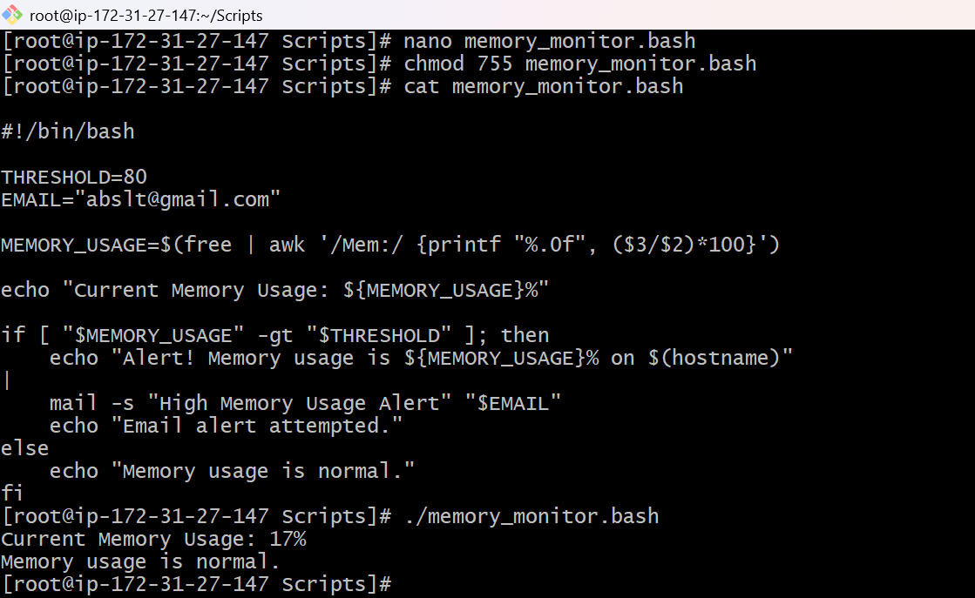
1. Create a script: The nano memory_monitor.bash command creates or opens a file to write the Bash script.
2. Set the threshold: THRESHOLD=80 means the maximum allowed memory usage is 80%.
3. Set the email: The EMAIL variable stores the email address that should receive an alert.
4. Check memory usage: The free command gets memory information, and awk calculates the percentage of memory being used.
5. Display memory usage: The echo command displays the current memory usage on the screen.
6. Check the condition: If memory usage is greater than 80%, the script attempts to send an email notification. Otherwise, it displays that memory usage is normal.
7. Give execution permission: chmod 755 memory_monitor.bash allows the script owner to execute the file.
8. Run the script: ./memory_monitor.bash executes the script and displays the result.

